The Toronto District School Board is launching School Cash Online, an easy to use, safe and convenient way for parents and guardians to pay for their children’s school fees, including agendas, yearbooks and class trips. To register for School Cash Online, please follow these step-by-step instructions.
NOTE: If you require assistance, select the SUPPORT option in the top right hand corner of the screen.
Step 1: Register
- If you have not registered, please go to the School Cash Online home page https://tdsb.schoolcashonline.com/
and select the “Get Started Today” option.

- Complete each of the three Registration Steps
*For Security Reasons your password, requires 8 characters,
one uppercase letter, one lowercase letter and a number.

Step 2: Confirmation Email

A registration confirmation email will be forwarded to you. Click on the link provided inside the email to confirm your email and School Cash Online account.
The confirmation link will open the School Cash Online site prompting you to sign into your account. Use the email address and password just created with your account.

Step 3: Find Student
This step will connect your children to your account.
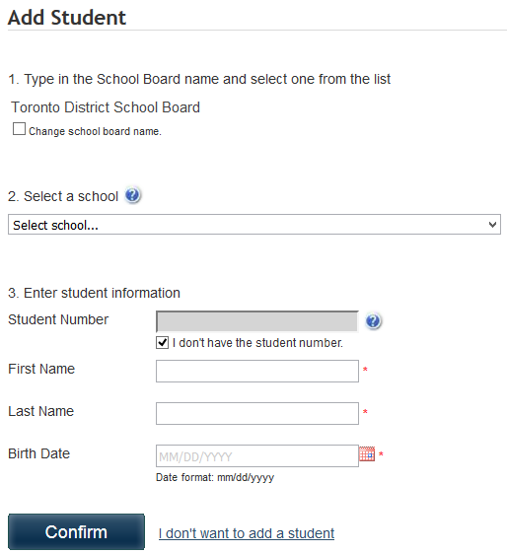
- Enter the School Board Name
- Select the School Name
- Enter Your Child’s First and Last Names
- Enter Your Child’s Date of Birth
- Select Confirm
- On the next page confirm that you are related to the child, check in the Agree box and select Continue
- Your child has been added to your account

Step 4: View Items or Add Another Student

If you have more children, select “Add Another Student” option and repeat the steps above. Five children can be added to one parent account.
If you do not wish to add additional children, select
“View Items for Students” option. A listing of available items for purchase will be displayed.

Stay connected! Be sure to select the option to receive email notifications when new items become available, selecting “Yes”.

